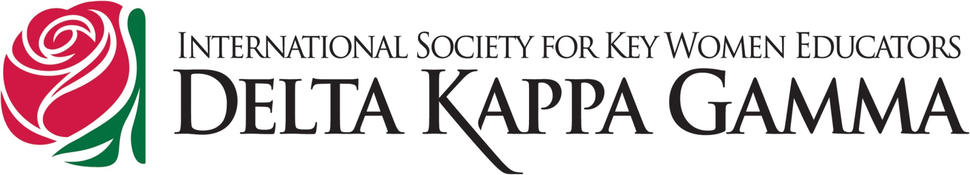
Certificate of Professional Growth
This certificate acknowledges that ___________________________ attended and participated in a professional development meeting in the area of:
Executive Board Meeting Committee Work Convention / Conference Attendance
Committee Chairman Officer Training (CCOT) Fall Arts Retreat
This meeting/session covered: and contributes to the participants’ knowledge, competence, performance and/or effectiveness related to education.
Number of hours/points earned: __________ (one hour equals one point)

Stephanie Walsh Date
Indiana State Organization President

Personal Growth and Professional Affairs Committee, Jo Drudge, Chairman

