BETA ALPHA ALPHABITS
November 2022 Number 3
Beta Alpha Chapter

Mission Statement:
The Delta Kappa Gamma Society International promotes professional and personal growth of women educators and excellence in education.

DKG: International and Indiana State Organization- Leading Women Educators Impacting Education Worldwide

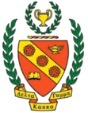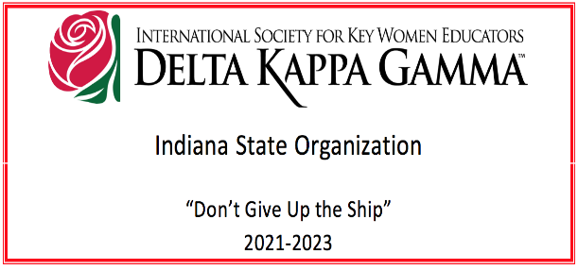

Beta Alpha Sisters,

Our Biltmore dinner was a wonderful evening last month. Thank you, Darlene, for hosting us all at your house (again!). Now we will transition to our holiday gathering. Get a turkey and an auction gift ready, RSVP to Gwen, and be ready to have some fun at SICTC!

Nothing has changed with the DKG State Convention in April since our last meeting, but I do plan to submit the form for a poster display for our chapter. I plan to get a tri-fold board and use the three sections to display information and pictures about (1) our meetings & themes, (2) our Teacher Locker project, and (3) our Book Club selections. The next Steering Committee Meeting will be Tuesday, November 29, at 6pm CST via Zoom. It is open for anyone to attend.

The Teacher Locker only has three shopping days left for teachers this semester. Then they will close and prepare for the spring. The teachers’ points will renew, and they can shop again if they choose to. We would love to have a day in the spring with several of us attending to help organize supplies and help teachers shop.

Our next book club selection is The Breadwinner by Deborah Ellis. It is a short fictional story based on real stories that the author heard while working at an Afghan refugee camp in Pakistan in the 1990s. The main character, Parvana, is a 10-year-old girl who must disguise herself as a boy to become the breadwinner for the family after her father is jailed by the Taliban for having a foreign education. This book is a series, and book #5 was just released last month. If you would like to join us in reading this book, we will meet on Tuesday, December 13, at 4:30pm at the McAlister’s on Green River Rd.

I am looking forward to seeing many of you at the next meeting on Tuesday, November 15th, at SICTC (with turkeys and auction gifts!)

Simone

Here are the important dates for this year:
Tuesday, November 15th Next Meeting See information in this newsletter.
Saturday, December 3rd (Brunch & Optional Cookie Exchange) See information in this newsletter.
Tuesday, March 21st
Friday-Sunday, April 28-30 (Indiana Convention)
Thursday, May 11th
**Details for all these dates are explained on the final pages of this newsletter.

OFFICERS OF BETA ALPHA 2022-2024
President - Simone Nance
Vice-President - Darlene Dycus
Recording Secretary – Carolyn Bucko
Corresponding Secretary – Angie Schonberger

Related Personnel
Past President/Council #12 Representative - Gwen Barnett
Treasurer – Marcia Onnybecker

Parliamentarian – Vickie Heilmann
Webmaster – Simone Nance

Chapter Committees 2022-2024
Society Business
Communications and Marketing –Darlene Dycus
Finance – Ann Vaughan
Membership – Angela Schonberger
Nominations – Simone Nance
Rules – Lorie Maltby

Program of Work
Program/Education Excellence – Carolyn Bucko
Scholarship –Darlene Dycus
International Projects and World Fellowship – Ethel Elkins
Legislation –Open. Please volunteer if you can.
Strategic Action Planning – Barb Nichols
Music – Vickie Heilmann

Next Meeting

Tuesday, November 15, at 5:30 p.m. at SICTC “Turkeys Away”
1901 Lynch Rd, Evansville, IN 47711

Please rsvp and include guests in the number that you give to Gwen Barnett by emailing her at gmb9965@yahoo.com.

Frozen turkey donations for HOSA. Bring a frozen turkey, or you may make a monetary donation.

Pound Auction Fundraiser with Carol Devillez as Auctioneer
Wrap something that weighs a pound in Christmas wrap. Bring money or a check to pay if you are the winning bidder on the pound item of your choice.

Dinner by Chef Sam (Chef Ed retired; Chef Sam is a former student of his.)
Chef Sam will be able to give a price when he knows how many people will be in attendance.

Soup, sandwich, and dessert will be the meal. There will be coffee, tea, and water for drinks.

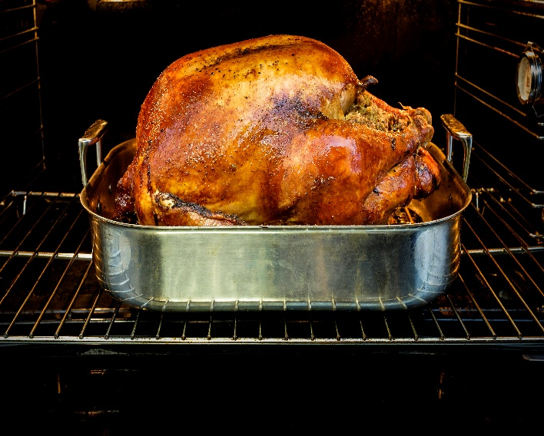

Annual Beta Alpha Christmas Brunch
With Optional Cookie Exchange

Saturday, December 3, at 9 a.m.
Darlene Dycus’s house at 7861 Ridgebrook Drive, Evansville, IN 47715

Please come to enjoy brunch and social time with Beta Alpha members. Guests are welcome!

The cookie exchange is optional. If you bring cookies, you will receive as many as you bring. Please bring an additional container or containers to collect your cookies in.

Please r.s.v.p. to Darlene at ddycus2059@aol.com by Thursday, December 1. Please let her know how many will attend and the kind of cookie you are making if you are bringing any.

Next Book Club Meeting
Tuesday, December 13, at McAlister’s on Green River Road at 4:30 p.m.

The next Book Club selection is The Breadwinner by Deborah Ellis.

It is a short fictional story about a 10-year-old girl, named Parvana, in Afghanistan. Her father was a history teacher, but the school is bombed and he loses his job. He began earning money by reading and writing for others who were unable. However, he is arrested by the Taliban for having a foreign education, and Parvana must disguise herself as a boy to become the breadwinner for the family.

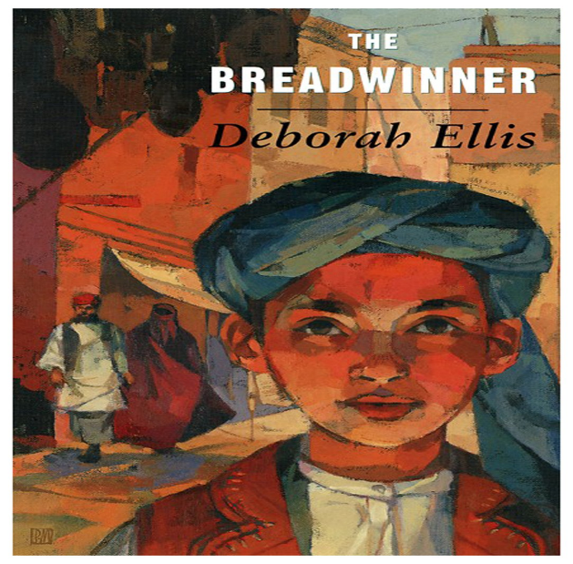

Previous book club meeting
A Girl of the Limberlost by Gene Stratton-Porter.

Previous Beta Alpha Meeting
Wednesday, October 19, 2022
“Meet Me in the Galley”

Biltmore Dinner, prepared by Darlene Dycus, with optional Biltmore wine pairings.
Presentation of the history of Biltmore as parallel to the history of DKG and women of the 1920’s and 1930’s.
We enjoyed the dinner with vintage dishes and crystal from the era of the opening of Biltmore to the public in 1930. And we shared the history of the founding of DKG by Annie Webb Blanton in 1929 and the history of the roles of women in North Carolina in 1929, where Biltmore is located. We also learned about the roles of women in general in the 1920’s and 1930’s. Our DKG founder was a pioneer in advancing the roles of women!
Our President, Simone Nance, conducted a meeting with important information about our chapter and about State and International DKG.
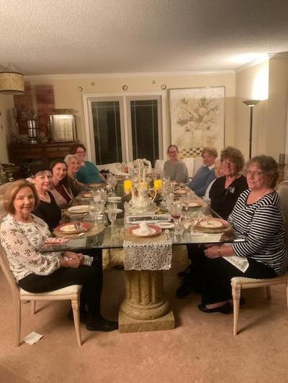
Members Present (Clockwise from Left)
Barb Nichols, Angie Schonberger, Simone Nance, Vickie Heilmann, Summer Aulich-Benford, Dr. Erin Reynolds, Carol Devillez, Carolyn Bucko, Gwen Barnett, Marcia Onnybecker
Not pictured: Darlene Dycus
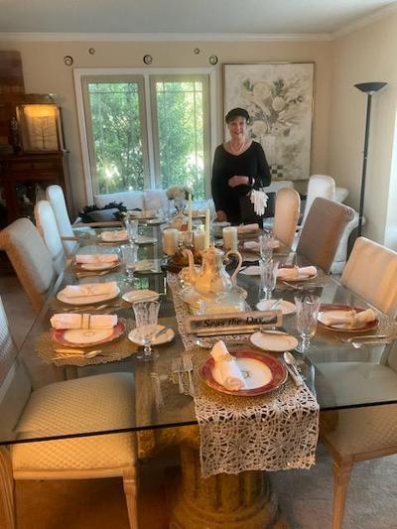
Angie Schonberger in Period Attire

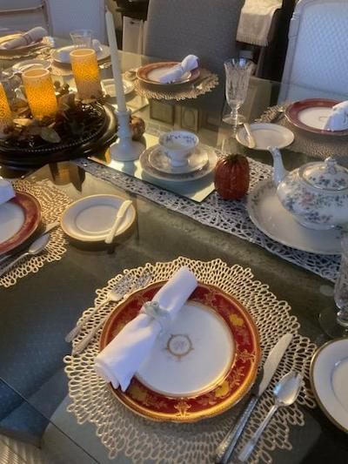
Period Dinnerware and Flatware

Community Education Support Project
Beta Alpha 2021-2023

Teacher locker is always in need of volunteers. Our President, Simone Nance, hopes that we will all find some time to volunteer since there are times open to help Teacher Locker with teacher “shopping” for much needed supplies.

Here is the link to sign up to volunteer: https://teachersfreestore.com/Evansville/ttlogin.aspx

Teacher Locker

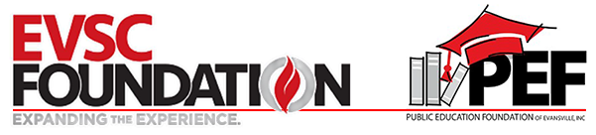

Supporting Teachers = Supporting Students
The Teacher Locker is a place where EVSC teachers grades Pre-K-12 can receive FREE school supplies for their classroom at no cost to the teacher. The goal is to reduce what teachers spend out of their own pockets for their classrooms. Please note this will not be a substitute for parents buying annual supplies as required by the EVSC or a location where parents receive free supplies for the year.

This is a six-way collaborative partnership between the EVSC; EVSC Foundation; Public Education Foundation of Evansville; Evansville Area Council PTA; Evansville Teachers Association and Evansville Retired Teachers Association.

MISSION STATEMENT

Teacher Locker is a place where the community can come together to provide free classroom supplies in order to support teaching, promote student achievement and drive school success.

VISION

EVSC Teachers will never have to worry about purchasing classroom supplies and materials out of their own pockets

  - MARK YOUR CALENDAR!
THE INDIANA STATE CONVENTION WILL BE IN EVANSVILLE!
APRIL 28-30, 2023
Location: Bally’s Tropicana Evansville Executive Conference Center
421 NW Riverside Dr, Evansville, IN 47708

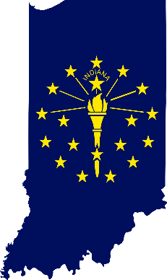

Beta Alpha representatives met with the Convention Committee and other chapter representatives on two occasions to survey the venue and to discuss assignments.
Beta Alpha has volunteered to be in charge of flowers.
Angie Schonberger has volunteered to create a sea or ship design for the main display in the convention center to represent the theme of “Don’t Give up the Ship.” We have been asked to prepare a poster display about our chapter. Our President, Simone Nance, will submit the form and prepare the poster.

Get to Know Your International Organization
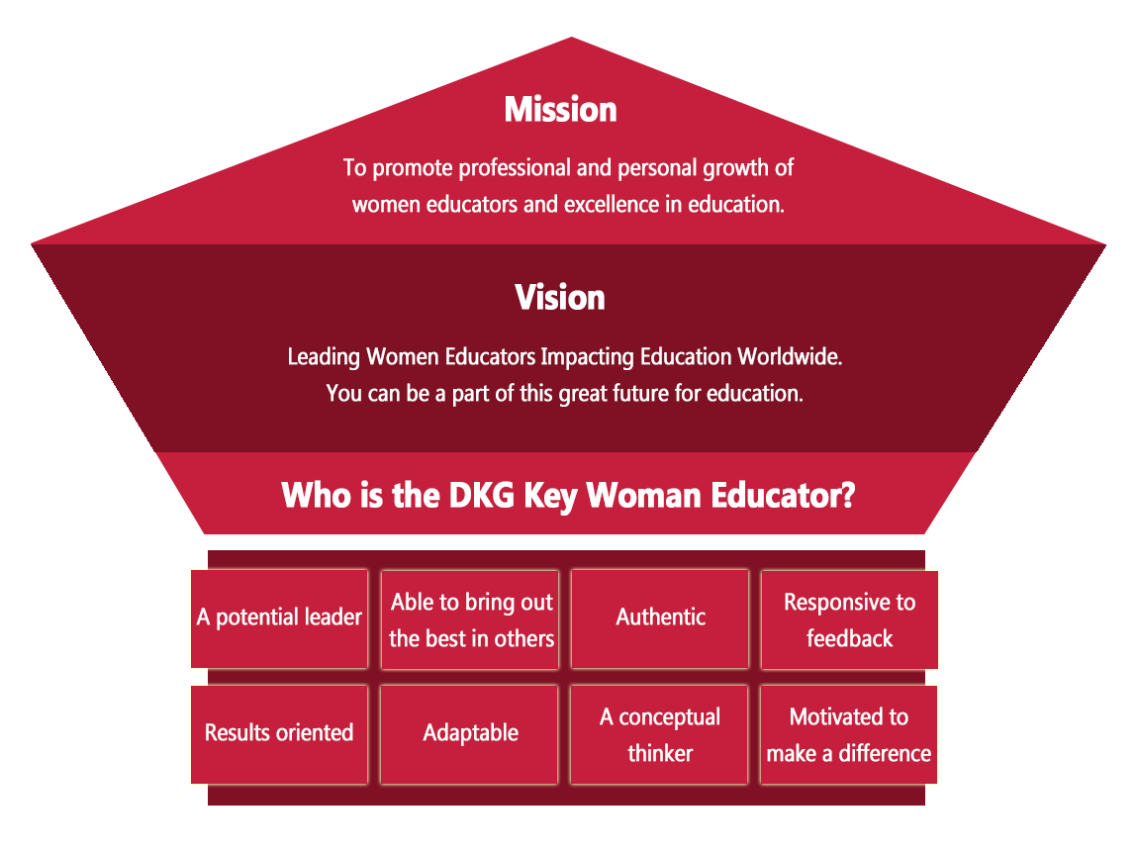

The Delta Kappa Gamma Society International
Join fellow DKG members for the Finland & Estonia Go Ahead Tour following the 2023 International Conference in Finland! Highlights include Sibelius Park, Temppeliaukio Church, Suomenlinna, Porvoo's Old City, Turku Cathedral, Tallinn, & more! Find details/book here: https://www.dkg.org/.../Go_Ahead_Tours.../Finland_2023.aspx
#dkgsi #DKGcon2023 #dkgief #keywomeneducators

The Delta Kappa Gamma Society International
Become an International Speaker!
Apply for a scholarship for an advanced degree!
Sign in to dkg.org and select the Apply/Submit tab » Applications. https://www.dkg.org/.../Apply_Submit/Applications.aspx

DKG Events! Mark your calendar!
Upcoming Events
Future Conventions:
National Harbor, Maryland (Gaylord National, D.C. Area) - 2024
Aurora, Colorado (Gaylord Rockies) - 2026
2023 Conferences
Michigan – Detroit, July 11-16, 2023
The Westin Book Cadillac
Arizona – Phoenix, July 18-22, 2023
Sheraton Wild Horse Pass
Finland – Tampere, July 26-29, 2023
Tampere Hall

Beta Alpha Chapter Highlights
Please see our Facebook page for all the latest!
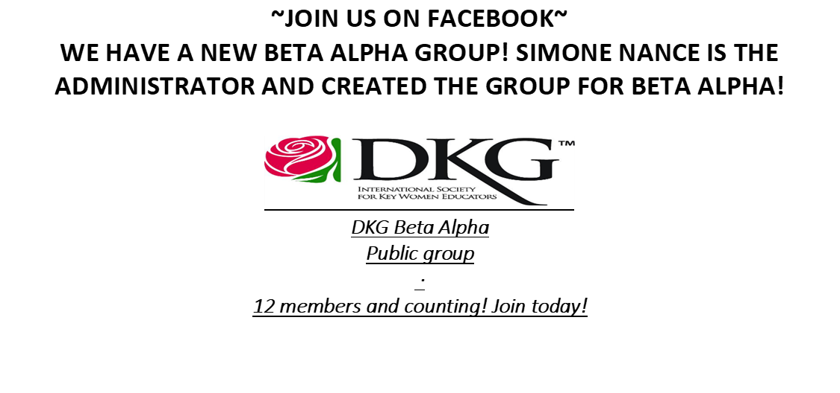
The Beta Alpha Chapter of DKG was founded in May 1960 and is located in Evansville, Indiana. The DKG organization is composed of women from all ages and backgrounds at local, state, and international levels that all aim to support and empower women in education. More information can be found at http://www.dkgbetaalpha.org/
Public
Anyone can see who's in the group and what they post.
Visible
Anyone can find this group.
Evansville, Indiana
General
MISSION The Delta Kappa Gamma Society International promotes professional and personal growth of women educators and excellence in education.
Vision
Leading Women Educators
Impacting Education Worldwide
Purposes
To unite women educators of the world in a genuine spiritual fellowship
To honor women who have given or who evidence a potential for distinctive service in any field of education
To advance the professional interest and position of women in education
To initiate, endorse and support desirable legislation or other suitable endeavors in the interests of education and of women educators
To endow scholarships to aid outstanding women educators in pursuing graduate study and to grant fellowships to non-member women educators
To stimulate the personal and professional growth of members and to encourage their participation in appropriate programs of action
To inform the members of current economic, social, political and educational issues so that they may participate effectively in a world society.

Member News
Dr. Ethel Elkins suffered the loss of her husband, David, on October 5, 2022, at the age of 69. Please support her at this difficult time. Here is a link to David’s obituary. https://www.simplecremationevansville.com/obituaries/david-a-elkins/

Carolyn Bucko needs our support as she continues to have treatments at Ohio State. She has some notable improvement in her voice and is hoping for other improvements.

Lorie Maltby continues to need our support in the transition of her mother to living in the local area from her home out of town.

Summer Aulich continues to need our support as she helps her parents.

Many of the members are enjoying wonderful times with children, grandchildren, family and friends and are enjoying their hobbies. Others are enjoying new and old careers. Fellowship at the meetings is a great way to learn about all of the members.
If you have any member news, please use the information at the end of the newsletter to send it to the editor. Pictures welcome!

SAVE THE DATE!
Tuesday, March 21, at 5:30 p.m. McCollough Library “O Captain, My Captain”
Presentation about DKG Leadership
Menu: Potluck appetizers/no dinner

Friday-Sunday, April 28-30, 2023, State Convention Bally’s Evansville Convention Center
Beta Alpha is in charge of the flowers. Beta Alpha will prepare a poster about our chapter.

Thursday, May 11, 2023, 5:30 p.m. “Sail into Summer”
Charcuterie Make and Take Lesson, including a charcuterie board to take home
Siciliano Subs and Charcuterie at Siciliano Subs
2021 W. Franklin St., Evansville, IN 47712
Cost: $50, payable in advance More details later

If you have member news, please forward your news to the editor at the address listed below.

Editor: Darlene R. Dycus
Vice President
Beta Alpha Chapter of DKG
ddycus2059@aol.com
7861 Ridgebrook Dr., Evansville, IN 47715
812-430-4666
NOTE: If you would like to volunteer to be in the Member Highlight, please contact Darlene Dycus at ddycus2059@aol.com with an autobiography via an “in text” document or an attachment. At present the member highlight is discontinued while waiting for volunteers. Please volunteer!
Or you may mail a written copy to the following address:
7861 Ridgebrook Dr. Evansville, IN 47715
Photos accepted and welcome!
If you have any other information for the newsletter, please also contact her at the contact information above.

