BETA ALPHA ALPHABITS
August 2022 Number 1
Beta Alpha Chapter

Mission Statement:
The Delta Kappa Gamma Society International promotes professional and personal growth of women educators and excellence in education.

DKG: International and Indiana State Organization- Leading Women Educators Impacting Education Worldwide

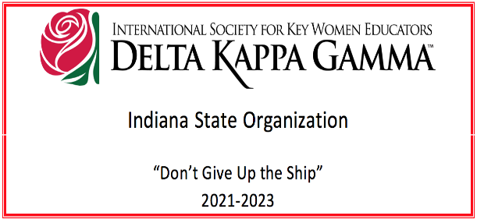

President’s Message
Hello, everyone!

I am so happy to kick off a new year with new opportunities! We are starting the year with a casual get-together potluck with minimal business so that we can just enjoy each other’s company for an evening. I look forward to hearing how everyone’s summer was and what is new in everyone’s lives. Please bring a guest, especially a guest who might want to join Beta Alpha. And please bring a donation for Teacher Locker. The list of needed items is below. We will have some fun DKG-based games, too, conducted by Carol Devillez.

I assume I am not the only one who has been very, very busy in the past few weeks. The public schools in the area are back in session, and the universities are now heading back, too, so many of us have been doing our best to prepare for students.

I do hope that many of you are able to help at the EVSC Teacher Locker in the coming months. Several of us have already been there to volunteer. And I know that I plan to return periodically to help. The donations we are collecting in September will help, but the volunteer work is important, too.

Please set aside the dates of April 28-30, 2023, to help support our State members with the State Convention being held at Bally’s downtown. The goal is to have about 100 members from around the state attend, and I am happy that our chapter will be a part of that goal. We will be able to work with members of the Pi chapter to support the state officers in any way we can.

Here are the important dates for this year:
Friday, September 16th (First Meeting, Potluck, Teacher Locker Donations)
Wednesday, October 19th
Tuesday, November 15th
Saturday, December 3rd (Brunch & Cookie Exchange)
Tuesday, March 21st
Friday-Sunday, April 28-30 (Indiana Convention)
Thursday, May 11th
**Details for all of these dates are explained on the final pages of this newsletter.

See everyone next month!

Simone

OFFICERS OF BETA ALPHA 2022-2024

President - Simone Nance
Vice-President - Darlene Dycus
Recording Secretary – Carolyn Bucko
Corresponding Secretary – Angie Schonberger

Related Personnel
Past President/Council #12 Representative - Gwen Barnett
Treasurer – Marcia Onnybecker

Parliamentarian – Vickie Heilmann
Webmaster – Simone Nance

Chapter Committees 2022-2024
Society Business
Communications and Marketing –Darlene Dycus
Finance – Ann Vaughan
Membership – Angela Schonberger
Nominations – Simone Nance
Rules – Lorie Maltby

Program of Work
Program/Education Excellence – Carolyn Bucko
Scholarship –Darlene Dycus
International Projects and World Fellowship – Ethel Elkins
Legislation –Open. Please volunteer if you can.
Strategic Action Planning – Barb Nichols
Music – Vickie Heilmann

Next Meeting

Friday, September 16, 2022, at 5:30 p.m.

Setting the Course
Potluck dinner at Darlene Dycus’s house: 7861 Ridgebrook Dr. Evansville, IN 47715

Bring a guest night! Bring Donations for Teacher Locker!

Most needed for Teacher Locker:
Composition Notebooks (wide & college ruled)
#2 pencils
Permanent markers (black & color)
Post it Notes
Color Printer Paper
Construction Paper
Crayola Markers
Crayola Crayons (no other brands)
Colored Pencils
Printer Paper
Anything else a teacher would use!
Please, no offbrand crayons, though. They break!

Lots of DKG-based games and fun conducted by Carol Devillez!

Please think of bringing a potential new member if possible. We’d love to have many to induct at the October meeting.

Please R.S.V.P. to Darlene at ddycus2059@aol.com or at 812-430-4666 via text or voicemail by Wednesday, September 14. Please include what dish you will bring to avoid duplicates.

We will pass out a survey to everyone about what they hope to benefit from with a Beta Alpha membership.

The next book club meeting
McAlister’s on Green River at 4:30 on Wed., Sept. 28.

Previous Book Club Meeting
This book was chosen for its relationship to the Ukraine

~JOIN US ON FACEBOOK~
WE HAVE A NEW BETA ALPHA GROUP! SIMONE NANCE IS THE ADMINISTRATOR AND CREATED THE GROUP FOR BETA ALPHA!

DKG Beta Alpha
Public group
·
12 members and counting! Join today!

Previous Beta Alpha Meeting on May 7, 2022
Fellowship

Mulberry Jean’s in Newburgh, Indiana
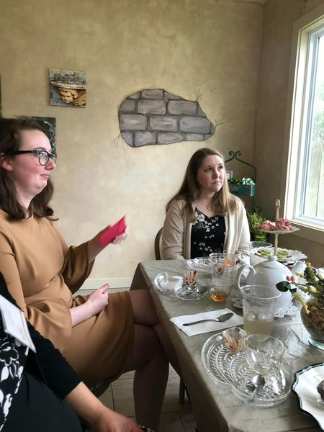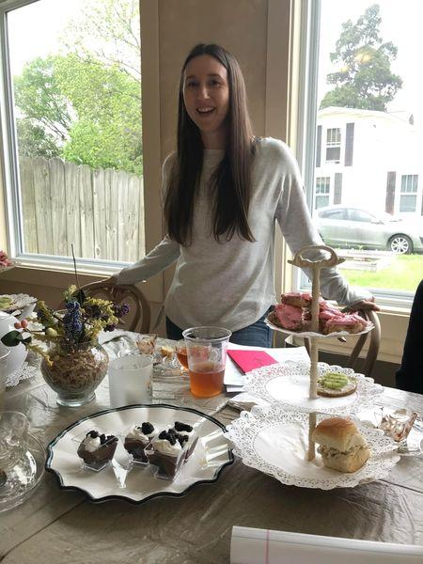
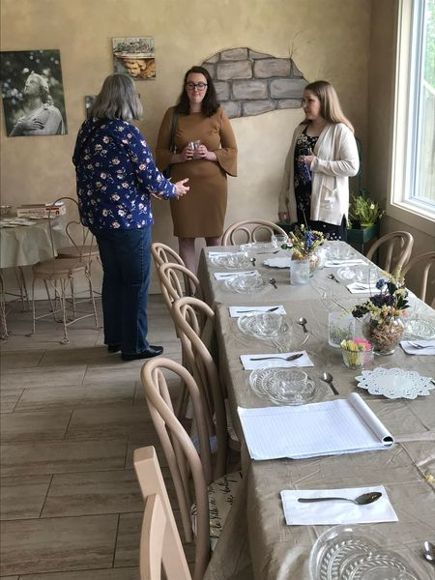

Top left to right and bottom left to right: Grant-In-Aid recipient Alexis, receiving her award; President Simone Nance, conducting the meeting; delicious luncheon and tea prepared by Mulberry Jean’s; member Lorie Maltby greeting Alexis and her soon-to-be mother-in-law. It was a wonderful social event and a productive meeting.

President Simone Nance conducted the meeting and discussed Beta Alpha, State and
International information and events.

Beta Alpha Planning Meeting
June 18, 2022

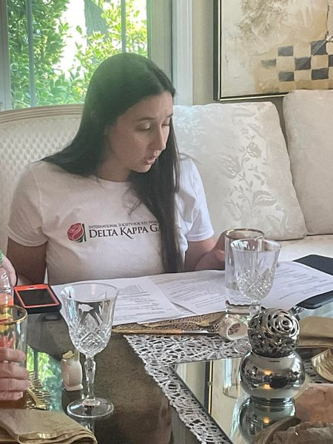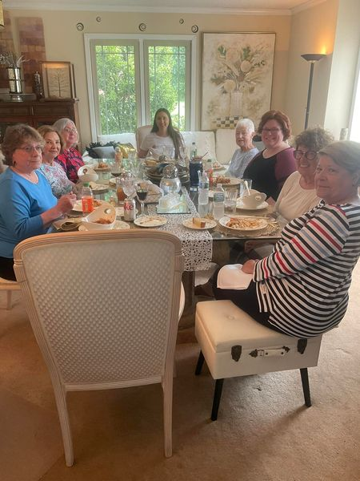

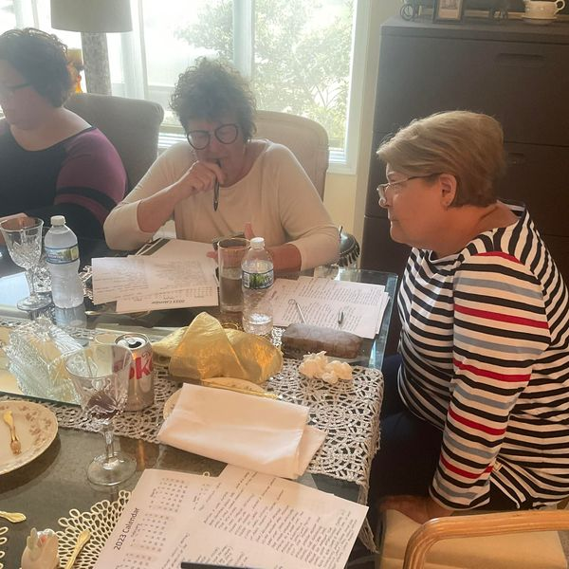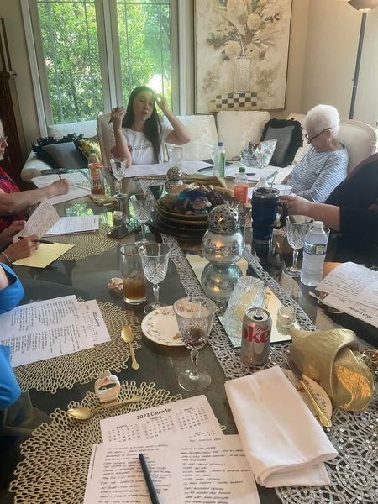

Community Education Support Project
Beta Alpha 2021-2023

Teacher Locker

Supporting Teachers = Supporting Students
The Teacher Locker is a place where EVSC teachers grades Pre-K-12 can receive FREE school supplies for their classroom at no cost to the teacher. The goal is to reduce what teachers spend out of their own pockets for their classrooms. Please note this will not be a substitute for parents buying annual supplies as required by the EVSC or a location where parents receive free supplies for the year.

This is a six-way collaborative partnership between the EVSC; EVSC Foundation; Public Education Foundation of Evansville; Evansville Area Council PTA; Evansville Teachers Association and Evansville Retired Teachers Association.

MISSION STATEMENT

Teacher Locker is a place where the community can come together to provide free classroom supplies in order to support teaching, promote student achievement and drive school success.

VISION

EVSC Teachers will never have to worry about purchasing classroom supplies and materials out of their own pockets

Beta Alpha Volunteering at Teacher Locker July and August 2022

Angie Schonberger, greeting EPL
Simone Nance, in the background, stuffing teacher with their donated supply delivery
supply bags.
  - 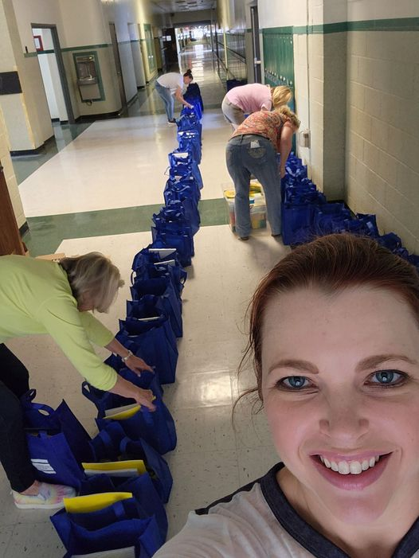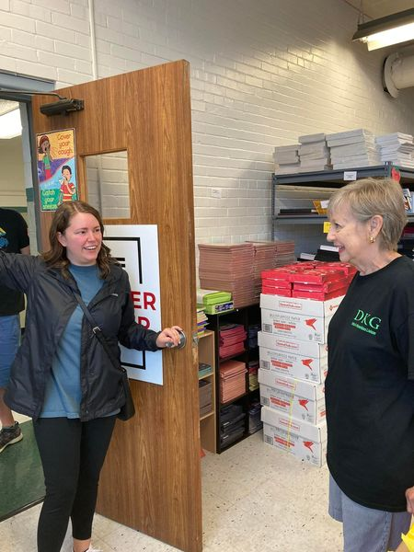
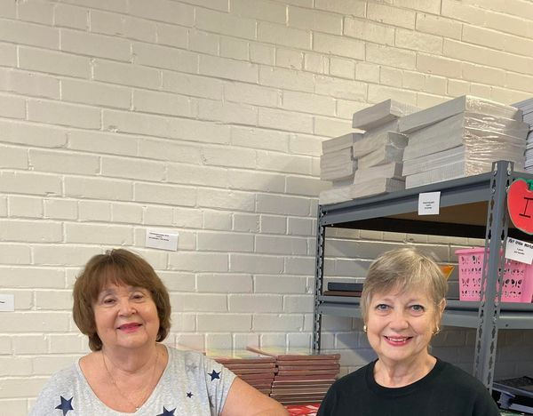
Darlene Dycus and Angie Schonberger,
helping on the first day of teacher “shopping.”

MARK YOUR CALENDAR!
THE INDIANA STATE CONVENTION WILL BE IN EVANSVILLE!
APRIL 28-30, 2023
Location: Bally’s Tropicana Evansville Executive Conference Center
421 NW Riverside Dr, Evansville, IN 47708

Beta Alpha representatives met with the Convention Committee and other chapter representatives on June 2, 2022, to survey the venue and to discuss assignments.
Beta Alpha has volunteered to be in charge of flowers.
Angie Schonberger has volunteered to create a sea or ship design for the main display in the convention center to represent the theme of “Don’t Give up the Ship.”

Sign Up to View the Convention Highlights Virtually!!!
The Delta Kappa Gamma Society International
August 11 at 12:09 PM ·
Register for the 2022 International Convention Highlights virtual event! On August 30–31, tune into select presentations from the convention! Or tune in later on demand! Those who attended the Convention in New Orleans will automatically be registered for this event free of charge.
Last day to register is Aug. 28th! More info/register here: https://www.dkg.org/.../2022_Convention_Highlights...
#DKGcon2022 #dkgsi #keywomeneducators

Get to Know Your International Organization
Check out its Facebook Page! Here are some excerpts!

The Delta Kappa Gamma Society International
August 10 at 3:08 PM
Wednesday is for Women!
Lucy Stone (1818-1893) was a passionate abolitionist and the founder of the Woman’s Journal, a leading women’s suffrage publication during the time. She was the first woman from Massachusetts to earn a college degree and is known as one of the first women to keep her maiden name when she married.

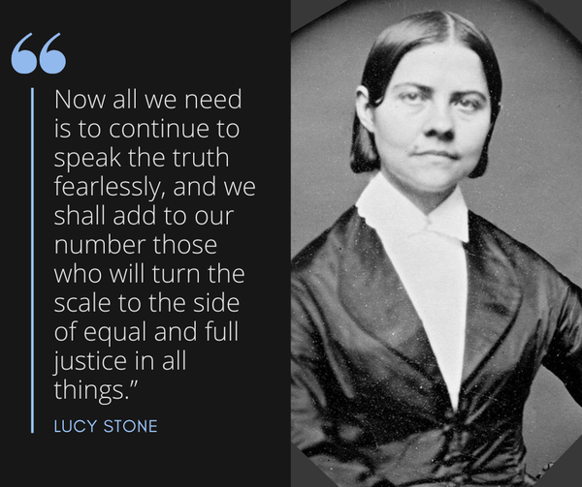

The Delta Kappa Gamma Society International
August 9 at 12:54 PM ·
The dkg.org website redesign is coming later this year! View the layout, a presentation, and give feedback here: https://www.dkg.org/DKGMember/Website_Redesign.aspx

The Delta Kappa Gamma Society International
August 8 at 12:17 PM ·
Applications are open!
Become an International Speaker!
Apply for a scholarship for an advanced degree!
Sign in to dkg.org and select the Apply/Submit tab » Applications. https://www.dkg.org/.../Apply_Submit/Applications.aspx

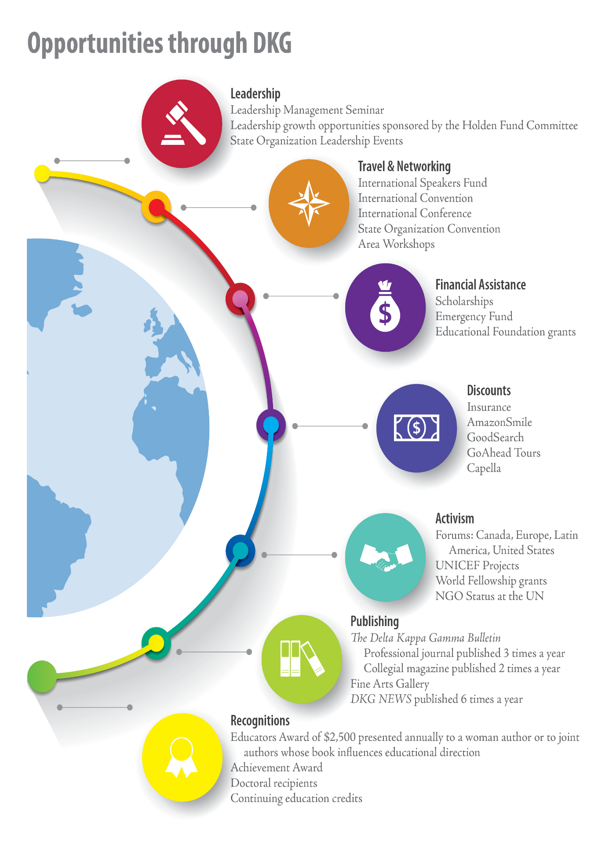

Beta Alpha Chapter Highlights
Please see our new Facebook page for all the latest!
The Beta Alpha Chapter of DKG was founded in May 1960 and is located in Evansville, Indiana. The DKG organization is composed of women from all ages and backgrounds at local, state, and international levels that all aim to support and empower women in education. More information can be found at http://www.dkgbetaalpha.org/
Public
Anyone can see who's in the group and what they post.
Visible
Anyone can find this group.
Evansville, Indiana
General
MISSION The Delta Kappa Gamma Society International promotes professional and personal growth of women educators and excellence in education.
Vision
Leading Women Educators
Impacting Education Worldwide
Purposes
To unite women educators of the world in a genuine spiritual fellowship
To honor women who have given or who evidence a potential for distinctive service in any field of education
To advance the professional interest and position of women in education
To initiate, endorse and support desirable legislation or other suitable endeavors in the interests of education and of women educators
To endow scholarships to aid outstanding women educators in pursuing graduate study and to grant fellowships to non-member women educators
To stimulate the personal and professional growth of members and to encourage their participation in appropriate programs of action
To inform the members of current economic, social, political and educational issues so that they may participate effectively in a world society.
Member News
Carol Winslow has moved and is now living at Leisure Living. She likes it there, and her children are helping her with selling her home.
Recently she was in the hospital for 3 days with an issue with one of her feet. She is doing much better now and is back at home at Leisure Living.
She continues to drive and plans on being at the next book club.
A recent email with corrections and/or updates to addresses for members, including Carol’s new address, was sent to email addresses on file for members. If you did not receive the updates, please contact Darlene Dycus at ddycus2059@aol.com or text or call 812-430-4666. Please leave a voicemail if no answer.

SAVE THE DATE!
Wednesday, October 19, at 5:00 p.m. “Meet Me in the Galley”
Darlene Dycus’s home at 7861 Ridgebrook Drive, Evansville, IN 47715
Biltmore Dinner, prepared by Darlene Dycus, with optional Biltmore wine pairings.
There will be a charge for the dinner and the wine pairings to cover the cost. It will be payable in advance to Darlene. More information later.
Induction
Presentation of the history of Biltmore as parallel to the history of DKG

Tuesday, November 15, at 5:30 p.m. at SICTC “Turkeys Away”
Frozen turkey donations for HOSA
Pound Auction with Carol Devillez as Auctioneer
Dinner by Chef Sam (Chef Ed retired; Chef Sam is a former student of his.)
More information on the cost of the dinner later.

Social Event: Saturday, December 3, at 10 a.m. Annual Beta Alpha Christmas Brunch and optional Cookie Exchange
Darlene Dycus’s house at 7861 Ridgebrook Drive, Evansville, IN 47715
More details from Darlene later.

Tuesday, March 21, at 5:30 p.m. McCollough Library “O Captain, My Captain”
Presentation by Stephanie Walsh, DKG State President
Menu: Potluck appetizers/no dinner

Friday-Sunday, April 28-30, 2023, State Convention Bally’s Evansville Convention Center
Beta Alpha is in charge of the flowers.

Thursday, May 11, 2023, 5:30 p.m. “Sail into Summer”
Charcuterie Make and Take Lesson, including a charcuterie board to take home
Siciliano Subs and Charcuterie at Siciliano Subs
2021 W. Franklin St., Evansville, IN 47712
Cost: $50, payable in advance More details later
If you have member news, please forward your news to the editor at the address listed below.

Editor: Darlene R. Dycus
Vice President
Beta Alpha Chapter of DKG
ddycus2059@aol.com
7861 Ridgebrook Dr., Evansville, IN 47715
812-430-4666
NOTE: If you would like to volunteer to be in the Member Highlight, please contact Darlene Dycus at ddycus2059@aol.com with an autobiography via an “in text” document or an attachment. At present the member highlight is discontinued while waiting for volunteers. Please volunteer!
Or you may mail a written copy to the following address:
7861 Ridgebrook Dr. Evansville, IN 47715
Photos accepted and welcome!
If you have any other information for the newsletter, please also contact her at the contact information above.

